Spring Oaks Football League
2024 RULES
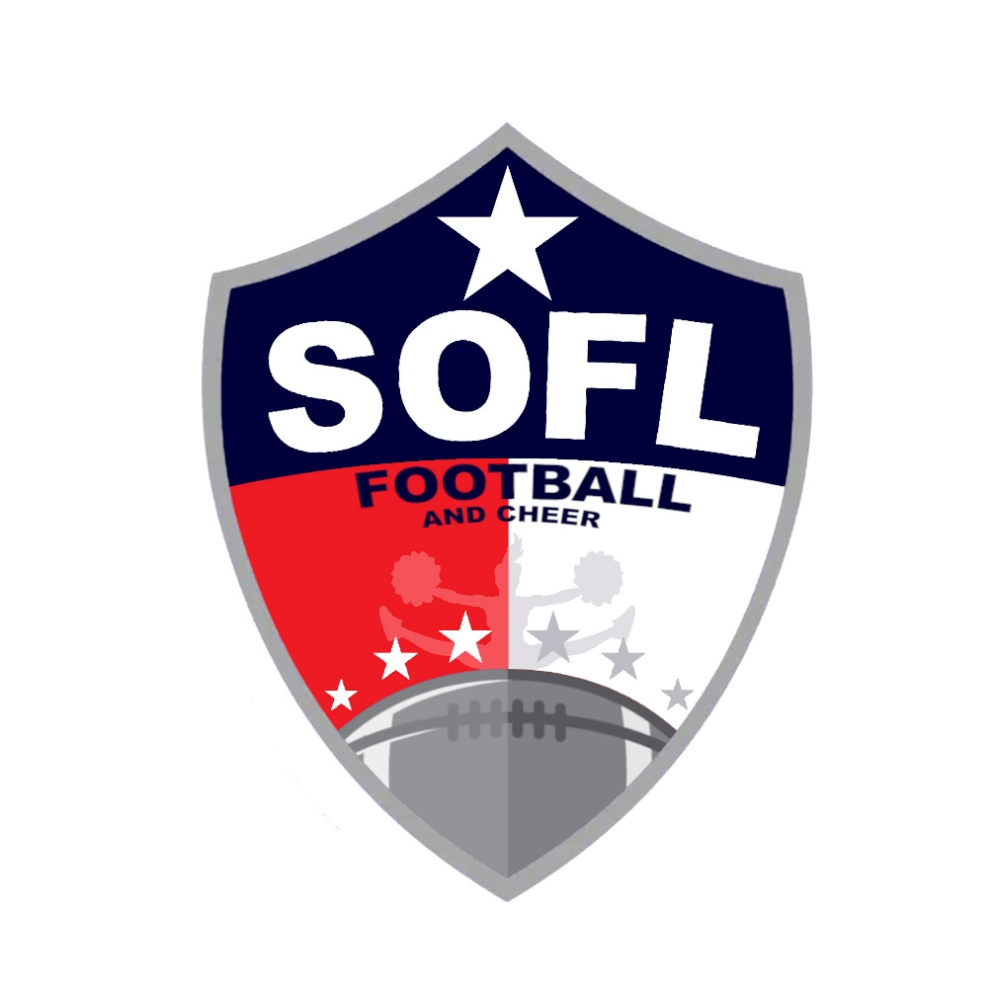
January 1, 2024

The Spring Oaks Football and Cheerleading League (SOFL) will follow the rules of the University Interscholastic League (UIL) and the National Collegiate Athletic Association (NCAA) with the additions, exceptions and clarifications listed in this document.

TABLE OF CONTENTS
1. CODE OF CONDUCT ... 2. RULES APPLICABLE TO ALL DIVISIONS ... 3. FRESHMAN RULES ... 4. SOPHOMORE RULES ... 5. JUNIOR AND SENIOR RULES ... 6. ENFORCEMENT OF RULES AND POLICY ... 7. POST-SEASON PLAY (ALL-STARS) ... 8. APPENDIX ...

1. CODE OF CONDUCT
1.1 All coaches, football and cheerleading participants, parents and spectators will abide by this Code of Conduct, which includes the following provisions. This code of conduct must be followed at ANY SOFL sponsored event, (i.e. games, practices, camps, etc). If any of these rules are broken, the Spring Oaks Football League Board of Directors (“Board of Directors”) shall have the authority to impose a penalty as detailed in Section VI, including, but not limited to immediate suspension of a minimum of one game and/or expulsion from the SOFL facility. To the extent this Code of Conduct conflicts with the then-current Parent Code of Conduct, these Spring Oaks Football League Rules shall control. Coaches, football and cheerleading participants, parents and spectators shall:
1.2 Not smoke, vape or use smokeless tobacco at the SOFL facility or any SOFL function.
1.3 Not criticize players or cheerleading participants in front of spectators, but reserve constructive criticism for later, in private, or in the presence of team/squad members if others might benefit.
1.4 Accept decisions of the game officials, judges, and Board of Directors on the field, in competitions and at Board meetings as being fair and called to the best ability of said officials/representatives.
1.5 Not criticize an opposing team, its players, cheerleading participants, coaches, officials, fans or SOFL Board Members by word of mouth or by gesture. Criticism shall be allowed in writing to the SOFL Board of Directors only!
1.6 Emphasize that good athletes strive to be good students and that they are both physically and mentally alert.
1.7 Strive to make every football and cheerleading activity serve as a training ground for life, and a basis for good mental and physical health.
1.8 Emphasize that winning is the result of good “teamwork.”
1.9 Coaches, together with game officials, shall be jointly responsible for the conduct and control of team, fans and spectators. Any fan who becomes a nuisance and out of control will be asked to leave. Any of the aforementioned may be asked to leave.
1.10 Not use abusive, profane or inappropriate language at any time.
1.11 Coaches shall not receive any payment, in cash or kind, for services as a coach in the Spring Oaks Football/Cheerleading League. This includes any coach, expert, consultant or choreographer, regardless of his/her roster status.
1.12 Coaches shall not permit or encourage “sweating down” tactics in order for a player to make the league’s “ball carrying” weight.
1.13 Coaches shall not recommend or distribute any medication, controlled or over the counter, except as specifically prescribed by participant’s physician. (Only the legal guardian may distribute medication of any kind.)
1.14 Not permit an ineligible player or cheerleading participant to participate in a game.
1.15 Not deliberately incite unsportsmanlike conduct.
1.16 Abstain from the possession and drinking of alcoholic beverages and the possession or use of any illegal substance at SOFL facilities.
1.17 Coaches shall remove from a game or practice any participant when even slightly in doubt about his/her health, whether or not as a result of injury, until competent medical advice is available.
1.18 Coaches shall control their fans. Remember, as a team coach, you’re responsible for your team, and fan reaction will usually be in step with your reaction. Coaches must apply a reasonable effort to control their fan base.
1.19 Not bring pets at the SOFL facilities.
1.20 Not bring glass containers at the SOFL facilities.
1.21 Not bring firearms at the SOFL facilities.
1.22 Prevent children from climbing trees, fences, bleachers, or entering the press boxes on SOFL facilities.
1.23 Not bring skateboards, bicycles, roller blades or skates in the park.
1.24 Uphold all rules and regulations provided by the SOFL in conjunction with all U.I.L. and NCAA rules.
1.25 Coaches shall not ask for any assistance from parents to pay for 2ndgame jerseys, or 2nd game pants.

2. RULES APPLICABLE TO ALL DIVISIONS
2.1 Events
2.1.1 All players may only participate in a maximum of four (4) events per week. An event is defined as a meeting with three (3) or more players and a coach and/or team parent engaging in football related activities (including, but not limited to, practice, football games, or viewing film). An official game counts as one event. Team parties not involving practice or instruction are permitted and are not counted as an event.
2.1.2 There will be no scheduled events for Sundays (games or practices) with the exception of games scheduled as post-season tournament play and/or make up games.
2.1.3 There will be no events between the draft and the first official practice.
2.1.4 Each potential violation of this rule will be reviewed by the board who shall determine penalties, if any, in its own discretion. The board reserves the right to review and hand out punishment in situations that, while technically within the letter of the rule, clearly violate the spirit of the rule. Examples of situations that would violate the spirit of the rule would be:
2.1.4.1 If a coach were to hold a series of scheduled practices with no more than 3 players between the draft and the first official practice when there are supposed to be no practices.
2.1.4.2 If a coach scheduled three players to show up at a 6:00 p.m. practice, then three different players to show up at 6:30 p.m., then three more at 7:00 p.m., etc.
2.2 Divisions (Age Groups)
- Freshman - 5 & 6 year olds
- Sophomore - 7 & 8 years olds
- Juniors - 9 & 10 year olds
- Seniors - 11 & 12 year olds
2.2.1 Player eligibility shall be determined by using July 31 of the current year as the cutoff date (i.e. the players age as of July 31 determines which division they play in). Parents may opt to have their child "play up" one year in play (for example, a 6-year-old playing with the 7 & 8 year-olds). Under no circumstances will any player be allowed to "play down," play up by more than one year (i.e. a 9 year old cannot play up in the Senior division (11/12s) or play in two (2) different divisions. Players are eligible to play within their own respective age group based on age eligibility.
2.2.2 Proof of Age: A certified copy of a birth certificate bearing the seal of the issuing office of the state of birth is required. Absent a birth certificate, a document that is approved by the Board of Directors is required.
2.3 The Division Weight Limitations For Players Who Can Run The Ball
- Freshman - 75 lbs
- Sophomore - 100 lbs
- Junior - 125 lbs
- Senior - 150 lbs
2.3.1 Player weights are without helmet, shoes/cleats or pads.
2.3.2 A medical scale shall be used to weigh every player. The medical scale shall be one that is preset to the applicable Division Weight Limitation.
2.3.3 Coaches shall provide a team roster for review by an SOFL board member and both coaches must be in attendance and supervise weigh in. Each team shall have all of its players weighed prior to the start of each game during the season to ensure the weight limitation is being maintained. To prevent controversy, the game day weigh-in is mandatory and cannot be waived or modified by anyone, including the coaches. Weight check by challenge or other than the above-prescribed method is not acceptable. A coach (or team) who plays a player who exceeds the applicable weight limitation in a game shall be subject to any or all of the following penalties: unsportsmanlike conduct, ejection from the game, forfeit of the game, and suspension from the next scheduled game. A player who violates the above weight limitation may be subject to the same penalties. Both coaches at weigh in must sign the completed index card. Signing of the index card ends the weigh in. Late arrivals will be allowed to participate; however, the child must be weighed in and will not be allowed to participate in the backfield or at tight end.
2.3.4 Football players weighing over the applicable weight limitation may not line up in the backfield for any reason, regardless of whether they carry the ball including as a kicker for extra points. A player exceeding the weight limit by a maximum of 20 pounds may line up as the “Tight End” and be eligible to catch a forward pass thrown past the line of scrimmage (screens, laterals. etc. are NOT permitted!). A “tight end” is defined as an eligible receiver no more than four yards from the middle of the offensive formation. In addition, players weighing over the applicable weight limitation may advance the ball on a fumble, blocked punt or interception that they recover or that falls into their hands (they cannot advance a ball received on a kickoff-see below). Players weighing over the applicable tight end weight limit may not line up in the tight end position regardless of rather or not they actually catch a pass.
2.3.5 Players who weigh over the applicable weight limitation may not line up deep in kickoff or punt formations to accept the ball (they must line up on the front row). Front row is defined as row of players closest to the ball. If a player over the applicable weight limit receives the ball, the ball cannot be advanced and the referee will blow the whistle.
2.4 Length of Games 2024 Rules
- Freshman - Four (4) 6 minute quarters
- Sophomore - Four (4) 7 minute quarters
- Junior - Four (4) 8 minute quarters
- Senior - Four (4) 9 minute quarters
Clock is not continuous during play.
2.5 Regular Games
2.5.1 A regulation game is the completion of play of a game in its entirety.
2.5.2 Games halted for inclement weather may be rescheduled by the SOFL. Resumed games will be started where play was suspended. The Board of Directors (or their authorized representative) on duty at the park will be responsible for weather decisions and game time changes. Game times may be changed in the event of inclement or unforeseen circumstances and are subject to same day or alternate day postponement. Example: A thunderstorm forces the postponement of the first game of the day. The storm passes and the first game of the day is now rescheduled to the last game of the day. All other game times remain the same.
2.5.3 If at the end of regulation play a tie exists, both teams will return to their sidelines and the team captains responsible for calling the coin toss will meet with the referees. The visiting team is responsible for calling the first coin toss/flip. The winner of this coin toss may choose to accept (start on offense) or refuse the ball (start on defense). The loser of the coin toss will decide which end zone overtime will be played in. Each team will receive the ball on the 25-yard line. A first down can be made in this scenario. If a tie still exists after both teams have attempted to break the tie each from the 25-yard line, the ball will be placed on the 10-yard line of the same end zone, change of possession will take place and play will resume. There will be no flip-flop of end zones unless field conditions dictate a need for change. The referees will determine this. Each team will again receive the ball for four (4) offensive plays. There is no chance of a first down being made at this point to extend the numbers of plays to more than four (4), except in the event of a defensive penalty. A turnover by mishap (fumble, interception, failed kick attempt, etc.) or loss of possession (loss on downs, penalty, etc.) concludes a team's possession of the ball in all situations. A tied game will be played until a winner is declared. The ball will remain at the ten (10) yard line for subsequent tries until a winner is determined. Each team receives one timeout per tiebreaker attempt.
2.6 Minimum Playing Time: (All teams must field at least 10 players except for a freshman team).
Minimum play time rules will be determined by division and will depend on the number of players on the division’s rosters at the conclusion of the draft. The grid below outlines the standard rule. Based on league numbers (coaches and registered players), modifications to this rule can be made and deemed in effect if approved by the league’s Competition Committee (President, Vice 2024 Rules President and Division Commissioners). Any modifications to this rule will be communicated to all coaches no later than the first practice.
Division Average# of Players per team
Minimum Play Rule
- Freshman - 6 plays
- Sophomore – 8 plays
- Junior – 10 plays
- Senior – 12 plays
2.6.1 The above rule is applied at the Division level and not a team by team basis. For example, if nine teams in a division have 17 players and 1 team has 18 players, then that division has an average number of players per team of 17.1 and the entire division (including the team with 18 players) will apply the minimum play rule.
2.6.2 Play Rule – minimum plays must be met by every team. If the deficit is 24 points or higher, there is no minimum play rule.
2.6.2.1 Special teams’ plays do count towards the minimum play number.
2.6.2.2 Plays where penalties have been incurred after the snap do count toward the minimum play number.
2.6.2.3 Dead ball fouls do not count toward the minimum play number.
2.6.2.4 Coaches will be responsible for counting the opposing team’s number of plays per participant.
2.6.3 A player who does not participate in regularly scheduled practices and/or needs to be disciplined for his/her conduct can be suspended for a game (or on a per-quarter basis) by his/her coach. The coach must provide written notice (per 2.6.2 above) to the Board of Directors and/or commissioner and the opposing coach of the game for the suspension to be carried out. The opposing coach can appeal the disciplinary action and the action must be approved by the respective commissioner. All decisions made by the competition committee on such suspension shall be final.
2.6.4 Parents or guardians (and only parents or guardians) may voluntarily withhold their 2024 Rules children from participating in the game.
2. 6.5 A coach who violates the minimum play rule may be suspended for the next game and will forfeit the game in question. Video is critical criteria of proof and the burden of proof rests with the team that submits the protest.
2.6.6 No minimum play time is required during all-star tournament play.
2.7 Uniforms and Equipment
2.7.1 Only league issued uniforms are allowed during games. Exceptions must meet board approval.
2.7.2 All league players must wear mouthpieces at all contact practices and games.
2.7.3 All players must wear a properly fitted helmet with facemask meeting safety standards. Shoulder, hip, knee, thigh, and tailbone pads are required for all contact practices and games. Shoes can either be the molded rubber type of sole/cleat or the plastic removable cleats. If the plastic removable cleats are used, wear and tear may cause metal to show through the plastic. If any metal shows through the plastic will be considered an illegal shoe. Metal cleats (baseball or track) are not permitted.
2.7.4 Game Balls are as follows:
- Freshman - Wilson K-2, MacGregor MXP, Nike 1000KComposite, Armour Composite 395 Peewee
- Sophomore - Wilson K-2, MacGregor MXP, Nike 1000K Composite, Armour Composite 395 Peewee
- Juniors - Wilson TDJ, MacGregor MXJ, Nike 1000J Composite, Armour Composite 395 Junior
- Seniors - Wilson TDJ, MacGregor MXJ, Nike 1000J Composite, Armour Composite 395 Junior

The home team is responsible for providing a ball. However, teams may play with a ball of their own choosing.
2.7.5 Hosting league will be required to provide scrimmage vests for teams with similar color jerseys. Visitors will wear the scrimmage vests. Hosting league will make sure scrimmage vests are cleaned after previous use.
2.8 Coaches
2.8.1 Coaches and assistant coaches must submit an application to the League requesting the opportunity to coach a team.
2.8.2 The board will conduct interviews in order to determine qualifications of applicant.
2.8.3 A subcommittee of the SOFL Board (The Competition Committee) shall select coaches deemed appropriate. Coaching at SOFL is a privilege, not a right, and the SOFL board maintains 100% authority and discretion over whom it may permit to coach.
2.8.4 Once a head coach is selected, the head coach may choose one official assistant coach prior to the first Combine session and that selection must also be approved by the Competition Committee.
2.8.5 Once the season has started, other assistant coaches may be allowed to participate and up to 5 coaches may be on the sidelines of an official game. SOFL maintains 100% authority and discretion over who it may permit to be on the sideline of any game.
2.8.6 The Competition Committee may choose a coach out of necessity during the Combine period. In the event of this situation, the head coach will be allowed to select an official assistant coach at that time.
2.8.7 SOFL will offer at least 3 Combine sessions prior to the start of the season for the opportunity for coaches to observe the registered players.
2.8.7.1 Once a head coach and an official assistant coach have been selected for a team and approved by the Competition Committee, their children shall be labeled as “freezes” for draft purposes. (See definition of “freezes” – Below)
2.8.7.2 Defining a “freeze”: A player that is defined as “frozen” will be removed from the freedraft and automatically be placed on a specified team. In return, the coach relinquishes a pick in the draft during a specified round for each frozen Player. The coaches in conjunction with the Division Commissioner will be charged with ranking the two “freezes” through a consensus or vote. Example: Player A is ranked #1 and Player B is ranked as a #5 round draft pick by the coaches and Division Commissioner. Team X would not be allowed to choose a free Player in either of those respective rounds because their “frozen” Players would account for those picks.
2.8.8 Coaches are responsible for their conduct at all times. Any alleged violation by a coach of any league rule will be investigated by the board, including interviews of the coach and all witnesses. Subsequent punishment, if any, of the coach, will be at the sole discretion of the board. Punishment will depend upon many factors, to include but not limited to the severity of the conduct, the coach’s handling of the situation prior to, during and subsequent to the incident, the coach’s prior history with the league, etc. Punishment may range from none at all if the alleged violation was determined to be unfounded, to an oral or written reprimand, suspension from one or more games, or permanent removal from the league. The coach may appeal the punishment to the board but must supply the appeal in writing with all supporting documentation including video, email and written statements.

2.9 Combine
2.9.1 SOFL will offer at least 3 Combine sessions prior to the start of the season for the opportunity for coaches to observe the registered players. Additional Combine sessions may be conducted at the board’s discretion. All players must participate in a Combine session.
2.9.2 Players are required to be weighed and measured. At the Combine session, the players will be required to (but not limited to) run a timed 40 yd dash, run a timed agility test, attempt to catch a football thrown by a coach and tackle a tackling dummy.
2.10 The Draft
2.10.1 The draft for each division will be held separately after the Combine sessions. Each coach will draw numbers for draft positions prior to the start. Once a team has picked their draft position, teams will be allowed to trade this draft position before the draft starts.
2.10.2 The draft will be conducted in a snake format, (i.e. First Round: 1-2-3-4; Second Round: 4-3-2-1; Third Round: 1-2-3-4; etc.)
2.10.3 All “freezes” must participate in a Combine sessions. In the event that a “frozen” player did not participate in a Combine session, that player will automatically be frozen in the first round of the draft. If both “frozen” players on a specified team did not participate in a Combine session, these frozen players shall be deemed first and second round picks and no other players may be selected during these two rounds. In addition, if either of the “frozen” players does not participate in a Combine session, the head coach for that team will not be permitted to be on the sideline for the first game of the season.
In the event that there is a returning player that cannot participate in any Combine session, they may be designated as a “hat pick” at the board’s discretion. If designated a “hat pick,” the coaches will pick these players via a hat draw at the end of a draft.
2.12.10.40.5 In the event that there is a new player to the league who is registered but cannot participate in any Combine session, they will be designated as a hat pick and assigned to a team after all players who are eligible to be drafted have been selected. The Coaches will pick these players via a hat draw at the end of the draft.
2.10.6 Regulate & Age Balance Teams in all Divisions. Age allocation by division will be determined each year by dividing the number of players of a particular age by the number of teams in a particular division. Example: 50 qualifying 10 yr. olds within Junior Division divided by 5 Junior Teams equates to ten 10 yr. olds per team.
2.10.7 There will be a designated 10 minute period following the draft when coaches can trade players between teams. This time limit may be adjusted by the Division Commissioner. No trade of players will be allowed after the designated time frame.
2.10.8 Only 2 representatives per team will be allowed in the draft room. No person with a child in the free draft will be allowed to assist a team/coach during the draft process.
2.10.9 No Cell phones, pagers or other communication devices are allowed to be used during the draft process to contact an outside person in an attempt to assist with the draft.
2.11 Coach, Player and Parent Behavior
Coaches, players, parents and spectators are expected to conduct themselves in a respectful manner at all times. The use of profanity, obscene gestures, derogatory remarks or name- calling is prohibited and can be grounds for violator’s removal from park.
LSYFA Ejection Rule: In the event that an altercation occurs with a player, coach or parent arises and they are ejected from a LSYFA sanctioned game, the hosting league and referee chapter that the altercation occurs in will report the incident to LSYFA, providing the names of participants ejected and reason for ejection. Pending LSYFA Disciplinary Committee approval, the player, coach or parent will be ineligible to participate in the next game and this information will be forwarded to the teams’ next scheduled game regardless of park that the game is scheduled for. This LSYFA Ejection Rule will apply to all parks regardless if it is an SOFL game or an alliance game.

2.12 Coaches Responsibilities
2.12.1 Coaches will make every attempt at a minimum to teach fundamental blocking, tackling, and basic offensive plays and defensive plays.
2.12.2 All coaches must instruct their players to initiate contact while their heads are up. The league will not tolerate any deliberate initial contact by the top of the helmet (spearing) in a practice or game. Such infraction occurring a maximum of two (2) times in a game will result in immediate ejection of the player from the game. The referee on the field has full authority in this matter. Further, if video evidence is provided to the board subsequent to a game that confirms, in the board’s discretion, deliberate contact and violation of this rule, the board may suspend the player and/or the coach for one of more subsequent games, depending on the severity of the conduct.
2.12.3 Coaches are responsible for player hydration. Practices will have no less than three (3) water breaks and water must be made available at all times during games.
2.12.4 Five (5) adults are allowed on each team’s sidelines during games. The first violation in a game shall result in a warning being issued.
2.12.5 All coaches are required to attend the pre-season coaching meeting(s) and any other meeting requested by the board. Attendance at this meeting is mandatory! Failure to comply may result in the League revoking sideline privileges for the entire year.
2.12.6 The board reserves the right to impose a minimum of one game suspension for any violation of any league rule.
2.12.7 Coaches are responsible for their player’s parent’s behavior and can be penalized by the officials during a game for unsportsmanlike conduct if deemed necessary.
2.12.8 The home team is to provide the announcer and scorekeeper. The visiting team is to provide the chain gang crew. The chain gang crew will wear identifying vests provided by the league.
2.12.9 Player retention - Player retention is critical to the long-term success of the League and the coach is responsible for communicating to the division commissioner if a player is considering leaving the team. The division commissioner will contact the parents of the player in question to discuss the circumstances around the player’s decision to leave the team and feedback will be provided to the coach as applicable.
2.12.10 Practice time per division is as follows (including breaks):
- Freshman - 1 hr 15 min
- Sophomore - 1 hr 45 min
- Junior & Senior – 2 hrs
2.13 Field Dimensions and Restrictions
Dimensions
- Freshman – 60 x 30 yard field
- Sophomore, Junior, and Senior – 100 x 53.3 yard field
Interleague or tournament games will be played on the field assigned by the host team.
One person from each playing team is allowed in the press box for the purpose of filming the game. The home team will also provide an announcer and a clock operator. Opposing team coaches or parents are prohibited from the press box during the games. The use of any type of communication equipment for the purposes of relaying information from the press box to the coaching staff is prohibited.
2.14 Referee’s must be TASO football certified and wear referee uniform. A referee cannot be a board member or a coach of the League and cannot referee games involving relatives. There shall be 2 Referee’s for regular season Freshman games and 3 Referee’s for regular season Sophomore, and Junior games with 4 for Senior games.
2.15 If a team forfeits for any reason, then NO courtesy game or scrimmage game will be allowed. If a team forfeits during post season tournament play (TOC or AS), that team is disqualified from the tournament and is not eligible for a participation medal.
2.16 Coach Badging
2.16.1 All sideline coaches are required to wear a league issued badge that identifies the coach. Only coaches with a badge will be allowed on the sideline during games. If a team is missing a certified coach on game day, that team is allowed to pick up another sideline “substitute coach” from the team. This allows the head coach to always have 4 helpers available. The “substitute coach” will need to wear the league issued “substitute coach” badge.
2.16.2 All Coaches will be listed on the Affidavit/Roster.
2.16.3 For Alliance games, in the event that a Coach forgets or loses his badge, he must state this at weigh in, the Hosting League can then verify that the Coach is listed on the Affidavit/Roster. Hosting league can hold his driver’s license and provide him with a temporary sideline badge for the game that he must return to the league after the game.

3. FRESHMAN RULES
3.1 Two offensive coaches and one defensive coach are allowed on the field to call plays and assist in quick alignment of the players. After such assistance the coaches will back away and maintain a 10 yard distance from the line of scrimmage. Once the offensive line is set, no further instruction is to be given by either coach of either side until the play is whistled dead. Head coaches will receive a warning (before the game starts) from the referee for giving assistance to defensive players after the ball has been snapped. Penalties will apply as follows:
1st Offense: 10yd unsportsmanlike conduct.
2nd Offense: 10yd unsportsmanlike conduct & coach ejection from the game.
Encouragement or motivational comments are not deemed instructional.
Hurry Up Offense: Additionally, referees will allow a reasonable amount of time for the defense to realign based on how the offense comes to the line of scrimmage. Reasonable amount of time will be determined by the referees. In the event that a defensive coach is not being timely in realignment, the same penalties will apply as mentioned above.
3.2 All punts are free kicks that must be declared in advance of the kick. Once a free kick has been declared, the player will be allowed to punt the ball without the defense crossing the line of scrimmage. Once the kick has been made, the play is live and the receiving team may return the kick. No fakes are allowed on free kicks.
3.2.1 In the event that a Freshman team is inside of their own 10 yd line, then they can declare a 4th Down Declared Punt. The referee would then move the ball 20 yards forward from that point and the ball turns over on downs. To be clear, if the ball is spotted on the 10 yd line exactly, a 4thDown Declared Punt would not be allowed. The ball must be spotted on less than the 10 yd line to be able to declare the 4thDown Declared Punt.
3.3 Games are to be played with eight players. Three backs are allowed in the backfield (quarterback and two running backs) and both ends are eligible provided all parties are under the weight limit to carry the ball. Freshman are not allowed to line head-up (nose guard) over center. There must be a minimum of five players on the line. The two outermost linemen are eligible receivers (assuming they are uncovered) and must meet the Tight End weight limits (see below).
3.4 Ball carrier weight limit is 75 lbs. Tight ends may not exceed 95 lbs.

3.5 Extra Points:
- Run 1 pt
- Pass2 pts if caught in the end zone
- 1 pt if caught and run into the end zone
- Kick 3 pts
All extra point attempts are live contact.
3.6 Any team leading by 28 points must remove 3 players from their normal Offensive positions as chosen by the Opposing Head Coach. The 3 chosen players (QB/RB/SE/WR/TE) must be removed from the backfield and any Offensive position that they are capable of catching, handling or advancing the ball until the margin is less than 28 points. A team that goes ahead by 28 points may leave their normal Offense in to attempt the extra point (i.e. Team A is leading 23-0 and scores a touchdown to make it 29-0, the normal Offense may stay in to attempt the extra point). From this point forward the revised Offense must catch, handle or advance the ball until the margin is less than 28 points.
In the event that a 28 point deficit exists at the start of the 4th quarter, the clock will automatically run for the entire length of the 4thquarter. Additionally, the losing head coach can opt to run the clock early; he can do so in any quarter of the game.
3.7 No player shall line up on the center. (No nose guards) In addition, the defense will not hit or otherwise engage the opposing center in any way with the intent to disrupt or intimidate the snap or cause potential harm to the player. This is a safety issue. Freshman division only.
3.8 All defensive linemen must play in either a three or four point stance on the defensive front from Tackle to Tackle. Linebackers/Defensive Backs must line up outside of the box. Box is defined as Tackle to Tackle and Line of Scrimmage to the back foot of the largest Down Lineman. Alignment beyond the Defined box is not affected by this rule. Linebackers may be in a standing position to blitz. Failure to comply will result in the following penalties:
First Offense 15 yard Unsportsmanlike conduct
Second offense 15 yard Unsportsmanlike conduct and Head Coach ejection
Third offense Forfeit
3.9 All other rules will be in accordance with UIL and NCAA guidelines.

4. SOPHOMORE RULES
All rules are the same as the Freshman Division with the following exceptions:
4.1 No coaches are allowed on the field at any time. Coaches must stay between the 20 yd lines and are not allowed to cross over this boundary.
4.2 All punts are live with the exception of a team declaring a free kick within its own 20 yd line. Such kick must be declared to the referee and neither side may advance until the ball is kicked. No fakes are allowed on free kicks.
4.3 Maximum weight limit is 100 lbs to carry the ball (backfield). Tight ends may not exceed 120 lbs.
4.4 You can have a nose guard line up on the center except on punts and extra points.

5. JUNIOR AND SENIOR RULES
All rules are the same as the Freshman Division with the following exceptions:
5.1 No coaches are allowed on the field at any time. Coaches must stay between the 20 yd lines and are not allowed to cross over this boundary.
5.2 All kicks are live.
5.3 Maximum weight limit to carry the ball (backfield): Juniors = 125 lbs and Seniors = 150 lbs. Tight ends in Juniors may not exceed 145 lbs and 170 lbs in the Senior division.
5.4 You can have a nose guard line up on the center except on punts and extra points.
6. ENFORCEMENT OF RULES AND POLICY
6.1 Contact with Officials
If a player or adult should strike (hit) a game official, the player or adult shall be temporarily or permanently suspended from SOFL.
6.2 Radios and Communication Devices
No radios or other communicative devices shall be allowed during game situations to relay information to the coaching staff on the sidelines.
6.3 Blocking and Tackling Restrictions
Nose guards (except in the Freshman Division) may blitz or use slants. However, leg whipping, chop blocking, (offensive player engages defensive player above the waist and a second offensive player blocks the player below the waist); illegal blocks below the waist, face tackling or spearing techniques shall not be permitted. If video evidence is provided to the board subsequent to a game that confirms, in the board’s discretion, deliberate contact and violation of this rule, the board may suspend the player and/or the coach for one of more subsequent games, depending on the severity of the conduct.
For more specific definitions of illegal blocks below the waist, see Appendix:
Blocking below the Waist
NCAA Definitions
6.4 Formal Protests
Coaches may only formally protest the eligibility of a player or cheerleader (i.e. issues dealing with weight or age). The competition committee shall decide all other actions addressed herein. Protests must be made writing to the appropriate commissioner and shall require a $50 fee. Protests will then be addressed by the SCFL competition committee. All protests must be submitted within 48 hours of the conclusion of the game in question. The team submitting the protest must submit overwhelming clear evidence to support their claim.
6.5 Penalties
The board is entitled to decide upon penalties for player, parent or coach misconduct at its own discretion. Punishments may be handed out in situations involving, but not limited to, the endangerment of a juvenile, fighting, cheating, use of threatening and/or inappropriate language, lack of cooperation/obstruction, players showing disrespect for other players, coaches or adults, etc. Punishment will depend upon many factors, to include but not limited to, the severity of the conduct, the individual’s handling of the situation prior to, during and subsequent to the incident, the individual’s prior history with the league, etc. Punishment may range from none at all if the alleged violation was determined to be unfounded, to an oral or written reprimand, suspension from one or more games, or permanent removal from the league. Any individual receiving board punishment may appeal the punishment to the board but must supply the appeal in writing with all supporting documentation including video, email and written statements.

7. POST-SEASON PLAY (ALL-STARS)
7.1 Freshman
There should be only one All-Star Team in the Freshman division. This team may consist of up to 16 players and shall be coached by the Super bowl winning coach. If this coach opts out, the runner up has first right of refusal and so on down the line to the last coach in the division. Each coach will nominate players from his team; however, the Head Coach of the All-Star team makes the final determination on players selected.
7.2 Sophomore, Junior and Senior
There may be either one or two All-Star teams in these divisions. These teams may consist of up to 25 players each. If at the board’s discretion it is decided that there will be two All Star teams in one division, they will be separated by conference. If there is one team, it shall be coached by the Super Bowl winning team’s head coach. If there are two teams, one will be coached by the highest ranked coach from one conference (taking into account playoff performance first, then regular season) and the other will be coached by the highest ranked coach from the other conference. If either of these coaches opts out, the next highest ranked team’s head coach, from within the same conference, has first right of refusal and so on down the line to the last coach in the conference.
The coach of the All-Star team is allowed to select a desired number of players from his regular season team.

8. APPENDIX
Cut Blocking or Blocking below the Waist
Cut blocking outside the tackle box is illegal. Due to the age and different styles of teaching the cut block and defending it, cut blocks outside the tackle box are illegal.
Technique
There is a difference between a chop block, which is illegal, and a cut block, which is legal. The two are mistakenly referred to as the same thing.
A legal cut block occurs when an offensive lineman or back blocks a defensive player below the waist with his helmet/shoulder in front of the player. An illegal cut block occurs when an offensive player hits a defender below the waist from the side or back.
The chop block occurs when an offensive player blocks below the waist while the defensive player is already engaged with another offensive player. The defensive lineman becomes more vulnerable to injury simply because he cannot defend himself.
Proper technique to cut block has the offensive player focusing on the play side leg of the defender to achieve getting head across the front of the defender at the waist, hip or thigh. Once engaged push the whole body into the defender and bear crawl to drive defender back as far as possible. To defend against the cut block you have to stay low to the ground because the blocker is low. As the blocker dives low use both your hands to keep blocker out in front of you and push them on the back down into the ground. At the same time the defender can use the blocker’s back as a way to balance his body so the defender can kick his feet back away from the blocker to protect his legs. As blockers are diving at legs either push them down as described or jump over them.
Note: No blocking below the waist on kick-off, kick-off return or punts. These are all change of possession plays and it is illegal to cut block at any time during these sets.
The issue becomes who can block below the waist toward the original position of the ball. Linemen who are no more than 7 yards from the snapper can block below the waist toward the snapper. Backs that are within the tackle box (if they were not in motion) can block below the waist toward the snapper.
*See NCAA definition document below.
NCAA Rule
RULE 9-1 / CONDUCT OF PLAYERS AND OTHERS SUBJECT TO RULES
Blocking below the waist is permitted except as follows (A.R. 9-1-2-IIIIX):
1. Offensive linemen at the snap positioned more than seven yards from the snapper are prohibited from blocking below the waist toward the original position of the ball in or behind the neutral zone and within 10 yards beyond the neutral zone.
2. Backs at the snap positioned with the frame of their body completely outside the tackle box, or in motion at the snap, are prohibited from blocking below the waist toward the original position of the ball in or behind the neutral zone and within 10 yards beyond the neutral zone. The frame of the body does not include arms or legs extended sideways (A.R. 9- 1-2-XXI).
RULE 2-27 / DEFINITIONS
Lineman and Back
ARTICLE 4
A lineman is any Team A player legally on his scrimmage line when the ball is snapped. An interior lineman is any Team A player legally on his scrimmage line and positioned between the end Team A players who are also on the line of scrimmage at the snap.
A back is any Team A player whose head or body does not break the plane of the line drawn through the rear-most part, other than the legs or feet, of the nearest Team A player (except the snapper) on the line of scrimmage when the ball is snapped. A lineman becomes a back before the snap when he moves to a position as a back and stops.
Definition of Tackle Box:
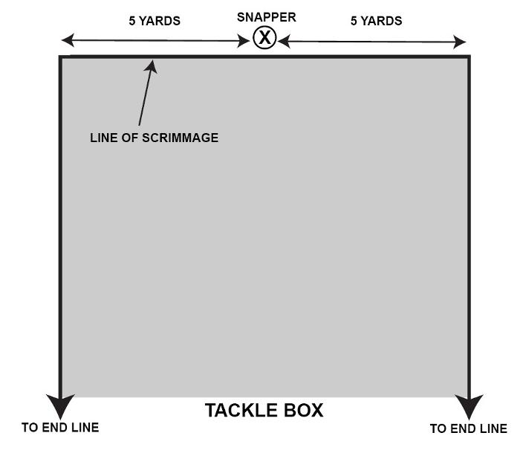

Examples
Approved Ruling 9-1-2
III. A1, an end, is positioned 11 yards to the outside of the snapper at the snap. B2 is between the original position of A1 and the sideline. A1 blocks B2 away from the position of the ball at the snap. The block by A1 is below the waist. RULING: Legal block (Rule 2-23-1-i).
IV. Quarterback A1 is forced to run out of his protecting pocket and scramble back and forth across the field. A2, a wide receiver positioned 12 yards outside the snapper, moves downfield and then returns toward the neutral zone. A2 then blocks B2 at the neutral zone and below the waist toward the ball at the snap. RULING: Illegal block. Penalty-15 yards (Rule 2-23-1-i).
V. On a run or pass option play, wide receiver A2 at the snap is positioned 12 yards outside the snapper. He moves downfield and then returns toward the neutral zone. A2 then blocks B2 eight yards beyond the neutral zone and below the waist toward the ball at the snap. RULING: Illegal block. Penalty-15 yards (Rule 2-23-1-i).
VI. A1, a flanker positioned to the left side of a formation, runs a deep reverse to the right side after receiving the ball from a teammate. A2, a spread end, at the snap is positioned 10 yards outside the snapper on the right side of the formation. A2 blocks B2, a defensive end, toward the ball. The block by A2 is below the waist and occurs behind or one yard beyond the neutral zone. RULING: Illegal block. Penalty-15 yards. Enforce at previous spot if foul occurs behind the neutral zone (Rule 2-23-1-i).
VII. A1, a wing back positioned 10 yards outside the snapper, goes in motion toward the ball before the snap. At the snap, his motion has carried him past the snapper. After the snap, A1 blocks B2 below the waist away from the ball at the snap. RULING: Legal block (Rule 2-23-1-i).
VIII. At the snap, flanker A2 is positioned 10 yards outside the snapper. As he moves toward the sideline he blocks a defensive halfback below the waist away from the ball. RULING: Legal block (Rule 2-23-1-i).
IX. At the snap, wing back A1 is positioned 10 yards outside the snapper and five yards behind the neutral zone. After the snap, A1 blocks B2 toward the ball at the snap. The block by A1 is below the waist and behind the neutral zone. RULING: Illegal block. Penalty—15 yards from the previous spot (Rule 2-23-1-i). Safety if the foul occurs behind Team A’s goal line.
XXI. Team A is in an unbalanced line scrimmage formation or any other unusual alignment at the snap. Back A27 is a potential blocker. RULING: If the frame of A27’s body is positioned completely outside the tackle box, he is prohibited from blocking below the waist toward the original position of the ball in or behind the neutral zone, and within 10 yards beyond the neutral zone.

